**Remove Duplicates from Sorted List**

Given the head of a sorted linked list, *delete all duplicates such that each element appears only once*. Return *the linked list****sorted****as well*.

**Example 1:**

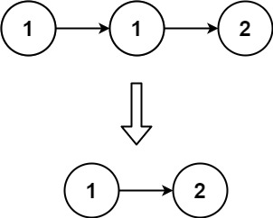

**Input:** head = [1,1,2]

**Output:** [1,2]

**Example 2:**

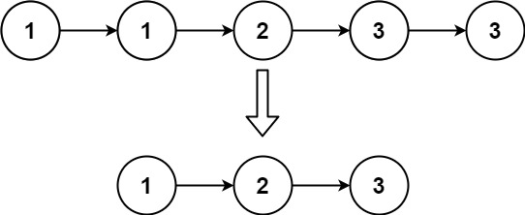

**Input:** head = [1,1,2,3,3]

**Output:** [1,2,3]

Solution:

class Solution {

    public ListNode deleteDuplicates(ListNode head) {

        ListNode current=head;

       while (current != null && current.next != null)

        {

            if(current.val==current.next.val)

            {

                current.next=current.next.next;

            }

            else{

                current=current.next;}

        }

        return head;

    }

}